SilaSave Instructions and Information

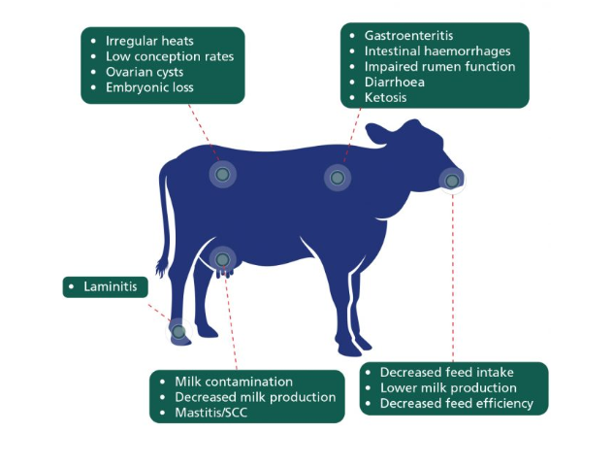
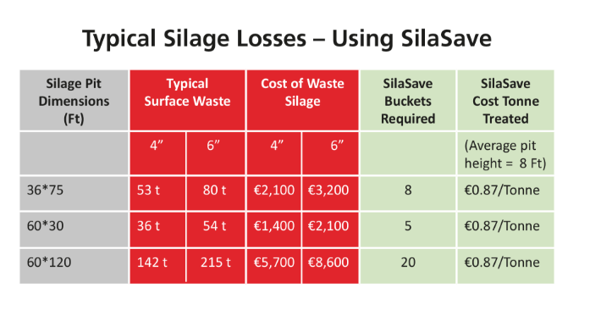

Feeding Instructions
Usage Instructions
Apply SilaSave at 500g per square yard to the top and sides of the
compacted/rolled pit prior to covering.
Following application of SilaSave, cover the pit immediately.
For example, typically a pit 30ft x 50ft will need 4 or 5 buckets for
total coverage.
Exercise good silage making practice when ensiling. SilaSave is a support and is not intended to replace good silage making practice.

